
Dear Parents, Guardians
We are pleased to advise that we will be using Jaybel Office Choice for the 2026 back to school packs. Jaybel is a 100% Australian family-owned & operated school supplier. We've been working with Jaybel to ensure your child has an easy start to the new year.
We have selected the best products and quantities that we believe will cover your child’s needs for the year.
Please ensure that your child has everything listed on this form to start the 2026 school year.

Placing Orders
- Ordering is fast, secure, and convenient. Simply visit www.jaybel.com.au/booklists
- Enter your school code and password, then follow the easy ordering steps.
- Your School Code: BTSBW001 & Password: BW2026

Important Delivery Information
- Orders placed before 19th December 2025 will receive FREE delivery. Orders placed after this date will incur a delivery fee of $9.95.
- To ensure your packs are delivered prior to school starting, please order before the 5th of January 2026
- Deliveries will commence on or before 9th December 2025. Orders are shipped with Authority to Leave and do not require a signature on delivery.
- Orders containing more than one booklist will be packed together in the same box.
- Once your order has been despatched, you will receive a tracking number via email.

Need Help?
For assistance with the website, your order, delivery information, or a general enquiry, please contact Jaybel Office Choice:
Email: sales@jaybel.com.au
Phone: 07 3423 5888
If your order hasn't arrived by January 15th, 2026, please contact us.
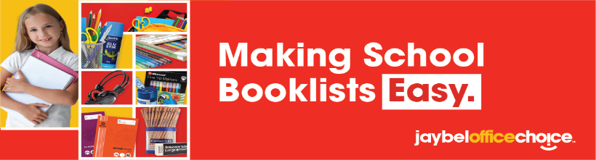
We look forward to a successful start to the 2026 school year.
Year 3
PRODUCT CODE | DESCRIPTION | QTY | INC GST | TOTAL
BTS-BK110007 | EXERCISE BOOK A4 8MM RULED 96 PAGES WITH MARGIN | 3 | $1.25 | $3.75
2843837 | OLYMPIC ECO EY39P EXERCISE BOOK QLD YEAR 3/4 A4 12MM RULED 96 PAGE EY39P RULED YEAR 3/4 96 PAGES | 4 | $1.83 | $7.32
BTS-BK110015 | SCRAPBOOK 335X240MM BLANK 64 PAGES | 2 | $1.87 | $3.74
BTS-BK110012 | GRID BOOK A4 10MM RULED 48 PAGES | 2 | $0.92 | $1.84
BTS-TI320001 | PREMIUM FACIAL TISSUES 2PLY BOX OF 200 | 1 | $2.06 | $2.06
BTS-DB160001 | REFILLABLE DISPLAY BOOK A4 20 POCKET ASSORTED COLOURS | 1 | $1.51 | $1.51
BTS-DW170003 | DOCUMENT WALLET FOOLSCAP PP WITH VELCRO CLOSURE ASSORTED | 2 | $0.78 | $1.56
522608 | STAEDTLER NATURAL GRAPHITE PENCILS HB PACK OF 12 | 2 | $3.85 | $7.70
521961 | BIC CRISTAL ORIGINAL BALLPOINT PEN MEDIUM 1MM RED | 2 | $0.55 | $1.10
BTS-SH290002 | SHARPENER METAL DOUBLE HOLE | 1 | $0.46 | $0.46
BTS-PR270003 | POLISHED WOODEN RULER 30CM | 1 | $0.58 | $0.58
BTS-CE120002 | SCHOOL ERASER LARGE | 4 | $0.33 | $1.32
BTS-GL190002 | BOSTIK GLUE STICK 35GM | 4 | $2.89 | $11.56
PLEASE CHOOSE ONE OF THE BELOW SCISSORS
BTS-SC280003 | SCISSOR 165MM RIGHT HAND | 1 | $2.60 | $2.60
BTS-SC280005 | SCISSOR 165MM LEFT HAND | 0 | $2.60 | $0.00
508730 | COLUMBIA COLOURSKETCH COLOURED PENCIL ROUND ASSORTED PACK OF 12 | 2 | $2.57 | $5.14
BTS-PC240002 | NAME PENCIL CASE 345X165MM LARGE | 1 | $2.39 | $2.39
522234 | TEXTA NYLORITE COLOURING MARKERS ASSORTED WALLET OF 12 | 2 | $2.35 | $4.70
501827 | FABER-CASTELL TEXTLINER HIGHLIGHTER ICE ASSORTED PACK OF 4 | 1 | $5.03 | $5.03
492972 | VERBATIM MULTIMEDIA HEADSET WITH MICROPHONE AND VOLUME CONTROL BLACK/GREY | 1 | $16.53 | $16.53
2749983 | HANDEE SUPER ABSORBENT ULTRA KITCHEN TOWEL 2 PLY 60 SHEETS DOUBLE PACK | 1 | $3.96 | $3.96
2286414 | EC WHITEBOARD MARKER THICK BLACK BOX OF 10 | 1 | $15.20 | $15.20
2794005 | VISIONCHART DOUBLE SIDED MAGNETIC WHITEBOARD TABLET A4 PLAIN BOTH SIDES | 1 | $6.56 | $6.56
BTS-CF140001 | PVC CLIPFOLDER A4 ASSORTED COLOURS | 1 | $2.94 | $2.94
 |  | Total Inc GST |  | $109.55

